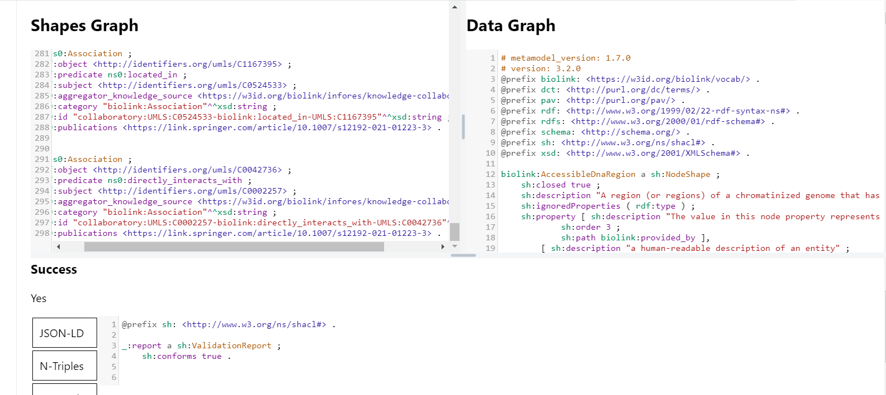

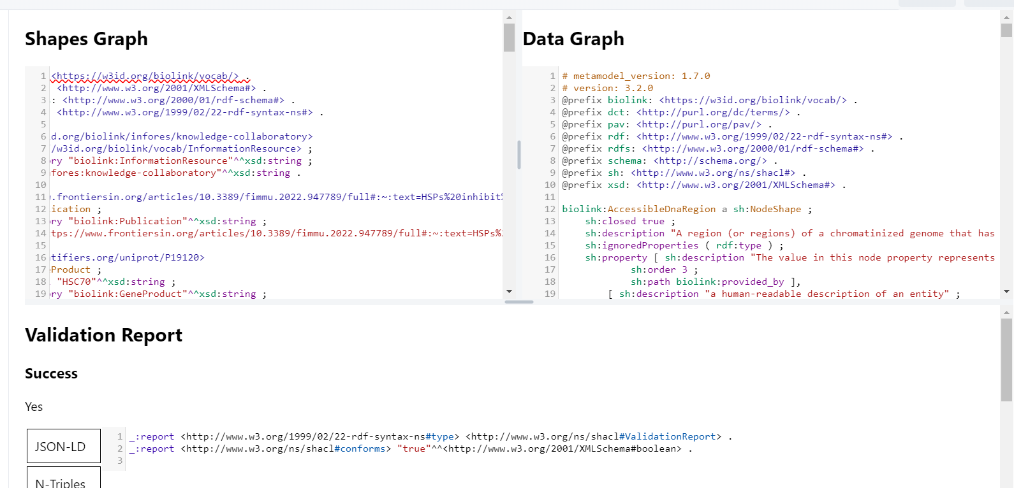

Example:

https://shacl-playground.zazuko.com/#page=2&shapesGraph=%40prefix+ns0%3A+%3Chttps%3A%2F%2Fw3id.org%2Fbiolink%2Fvocab%2F%3E+.%0A%40prefix+xsd%3A+%3Chttp%3A%2F%2Fwww.w3.org%2F2001%2FXMLSchema%23%3E+.%0A%40prefix+rdfs%3A+%3Chttp%3A%2F%2Fwww.w3.org%2F2000%2F01%2Frdf-schema%23%3E+.%0A%40prefix+rdf%3A+%3Chttp%3A%2F%2Fwww.w3.org%2F1999%2F02%2F22-rdf-syntax-ns%23%3E+.%0A%0A%3Chttps%3A%2F%2Fw3id.org%2Fbiolink%2Finfores%2Fknowledge-collaboratory%3E%0A++a+%3Chttps%3A%2F%2Fw3id.org%2Fbiolink%2Fvocab%2FInformationResource%3E+%3B%0A++ns0%3Acategory+%22biolink%3AInformationResource%22%5E%5Exsd%3Astring+%3B%0A++ns0%3Aid+%22infores%3Aknowledge-collaboratory%22%5E%5Exsd%3Astring+.%0A%0A%3Chttps%3A%2F%2Fdailymed.nlm.nih.gov%2Fdailymed%2FdrugInfo.cfm%3Fsetid%3D42c0a177-7d62-4bcf-9fce-7dd484cda4d5%3E%0A++a+ns0%3APublication+%3B%0A++ns0%3Acategory+%22biolink%3APublication%22%5E%5Exsd%3Astring+%3B%0A++ns0%3Aid+%22https%3A%2F%2Fdailymed.nlm.nih.gov%2Fdailymed%2FdrugInfo.cfm%3Fsetid%3D42c0a177-7d62-4bcf-9fce-7dd484cda4d5%22%5E%5Exsd%3Astring+.%0A%0A%3Chttp%3A%2F%2Fidentifiers.org%2Fumls%2FC1160689%3E%0A++a+ns0%3AOrganismTaxon+%3B%0A++rdfs%3Alabel+%22viruses+genomes%22%5E%5Exsd%3Astring+%3B%0A++ns0%3Acategory+%22biolink%3AOrganismTaxon%22%5E%5Exsd%3Astring+%3B%0A++ns0%3Aid+%22UMLS%3AC1160689%22%5E%5Exsd%3Astring+.%0A%0A%3Chttp%3A%2F%2Fidentifiers.org%2Fpubchem.compound%2F51346143%3E%0A++a+ns0%3AChemicalEntity+%3B%0A++rdfs%3Alabel+%22guanines%22%5E%5Exsd%3Astring+%3B%0A++ns0%3Acategory+%22biolink%3AChemicalEntity%22%5E%5Exsd%3Astring+%3B%0A++ns0%3Aid+%22PUBCHEM.COMPOUND%3A51346143%22%5E%5Exsd%3Astring+.%0A%0A%3Chttp%3A%2F%2Fidentifiers.org%2Fumls%2FC0162326%3E%0A++a+ns0%3AChemicalEntity+%3B%0A++rdfs%3Alabel+%22DNA+sequences%22%5E%5Exsd%3Astring+%3B%0A++ns0%3Acategory+%22biolink%3AChemicalEntity%22%5E%5Exsd%3Astring+%3B%0A++ns0%3Aid+%22UMLS%3AC0162326%22%5E%5Exsd%3Astring+.%0A%0A%3Chttp%3A%2F%2Fidentifiers.org%2Fumls%2FC1515655%3E%0A++a+ns0%3AOrganismTaxon+%3B%0A++rdfs%3Alabel+%22in+vivo%22%5E%5Exsd%3Astring+%3B%0A++ns0%3Acategory+%22biolink%3AOrganismTaxon%22%5E%5Exsd%3Astring+%3B%0A++ns0%3Aid+%22UMLS%3AC1515655%22%5E%5Exsd%3Astring+.%0A%0A%3Chttp%3A%2F%2Fpurl.obolibrary.org%2Fobo%2FNCBITaxon_11676%3E%0A++a+ns0%3AOrganismTaxon+%3B%0A++rdfs%3Alabel+%22Human+immunodeficiency+virus+%28HIV-1%29%22%5E%5Exsd%3Astring+%3B%0A++ns0%3Acategory+%22biolink%3AOrganismTaxon%22%5E%5Exsd%3Astring+%3B%0A++ns0%3Aid+%22NCBITaxon%3A11676%22%5E%5Exsd%3Astring+.%0A%0A%3Chttp%3A%2F%2Fpurl.obolibrary.org%2Fobo%2FNCBITaxon_10376%3E%0A++a+ns0%3AOrganismTaxon+%3B%0A++rdfs%3Alabel+%22Epstein%E2%80%93Barr+virus+%28EBV%29%22%5E%5Exsd%3Astring+%3B%0A++ns0%3Acategory+%22biolink%3AOrganismTaxon%22%5E%5Exsd%3Astring+%3B%0A++ns0%3Aid+%22NCBITaxon%3A10376%22%5E%5Exsd%3Astring+.%0A%0A%3Chttp%3A%2F%2Fid.nlm.nih.gov%2Fmesh%2FD000094302%3E%0A++a+ns0%3AOrganismTaxon+%3B%0A++rdfs%3Alabel+%22papillomavirus+%28HPV%29%22%5E%5Exsd%3Astring+%3B%0A++ns0%3Acategory+%22biolink%3AOrganismTaxon%22%5E%5Exsd%3Astring+%3B%0A++ns0%3Aid+%22MESH%3AD000094302%22%5E%5Exsd%3Astring+.%0A%0A%3Chttp%3A%2F%2Fidentifiers.org%2Fumls%2FC0034865%3E%0A++a+ns0%3AGeneProduct+%3B%0A++rdfs%3Alabel+%22recombination%22%5E%5Exsd%3Astring+%3B%0A++ns0%3Acategory+%22biolink%3AGeneProduct%22%5E%5Exsd%3Astring+%3B%0A++ns0%3Aid+%22UMLS%3AC0034865%22%5E%5Exsd%3Astring+.%0A%0A%3Chttp%3A%2F%2Fwww.reactome.org%2FPathwayBrowser%2F%23%2FR-BTA-9623433%3E%0A++a+ns0%3AGeneProduct+%3B%0A++rdfs%3Alabel+%22gene+expression+control%22%5E%5Exsd%3Astring+%3B%0A++ns0%3Acategory+%22biolink%3AGeneProduct%22%5E%5Exsd%3Astring+%3B%0A++ns0%3Aid+%22REACT%3AR-BTA-9623433%22%5E%5Exsd%3Astring+.%0A%0A%3Chttp%3A%2F%2Fidentifiers.org%2Fumls%2FC1567953%3E%0A++a+ns0%3AChemicalEntity+%3B%0A++rdfs%3Alabel+%22DNA+aptamers%22%5E%5Exsd%3Astring+%3B%0A++ns0%3Acategory+%22biolink%3AChemicalEntity%22%5E%5Exsd%3Astring+%3B%0A++ns0%3Aid+%22UMLS%3AC1567953%22%5E%5Exsd%3Astring+.%0A%0A%3Chttp%3A%2F%2Fpurl.obolibrary.org%2Fobo%2FNCBITaxon_208726%3E%0A++a+ns0%3AOrganismTaxon+%3B%0A++rdfs%3Alabel+%22hepatitis+A+virus+%28HAV%29%22%5E%5Exsd%3Astring+%3B%0A++ns0%3Acategory+%22biolink%3AOrganismTaxon%22%5E%5Exsd%3Astring+%3B%0A++ns0%3Aid+%22NCBITaxon%3A208726%22%5E%5Exsd%3Astring+.%0A%0A%3Chttp%3A%2F%2Fidentifiers.org%2Fumls%2FC1456463%3E%0A++a+ns0%3AOrganismTaxon+%3B%0A++rdfs%3Alabel+%22cauliflower+mosaic+virus+%28CaMV%29%22%5E%5Exsd%3Astring+%3B%0A++ns0%3Acategory+%22biolink%3AOrganismTaxon%22%5E%5Exsd%3Astring+%3B%0A++ns0%3Aid+%22UMLS%3AC1456463%22%5E%5Exsd%3Astring+.%0A%0A%3Chttp%3A%2F%2Fidentifiers.org%2Fumls%2FC5698146%3E%0A++a+ns0%3AOrganismTaxon+%3B%0A++rdfs%3Alabel+%22severe+acute+respiratory+syndrome+virus+%28SARS%29%22%5E%5Exsd%3Astring+%3B%0A++ns0%3Acategory+%22biolink%3AOrganismTaxon%22%5E%5Exsd%3Astring+%3B%0A++ns0%3Aid+%22UMLS%3AC5698146%22%5E%5Exsd%3Astring+.%0A%0A%3Chttp%3A%2F%2Fid.nlm.nih.gov%2Fmesh%2FD000998%3E%0A++a+ns0%3AChemicalEntity+%3B%0A++rdfs%3Alabel+%22antiviral+agents%22%5E%5Exsd%3Astring+%3B%0A++ns0%3Acategory+%22biolink%3AChemicalEntity%22%5E%5Exsd%3Astring+%3B%0A++ns0%3Aid+%22MESH%3AD000998%22%5E%5Exsd%3Astring+.%0A%0A%5B%5D%0A++a+ns0%3AAssociation+%3B%0A++rdf%3Aobject+%3Chttp%3A%2F%2Fidentifiers.org%2Fumls%2FC1160689%3E+%3B%0A++rdf%3Apredicate+ns0%3Aaffects+%3B%0A++rdf%3Asubject+%3Chttp%3A%2F%2Fidentifiers.org%2Fpubchem.compound%2F51346143%3E+%3B%0A++ns0%3Aaggregator_knowledge_source+%3Chttps%3A%2F%2Fw3id.org%2Fbiolink%2Finfores%2Fknowledge-collaboratory%3E+%3B%0A++ns0%3Acategory+%22biolink%3AAssociation%22%5E%5Exsd%3Astring+%3B%0A++ns0%3Aid+%22collaboratory%3APUBCHEM.COMPOUND%3A51346143-biolink%3Aaffects-UMLS%3AC1160689%22%5E%5Exsd%3Astring+%3B%0A++ns0%3Apublications+%3Chttps%3A%2F%2Fdailymed.nlm.nih.gov%2Fdailymed%2FdrugInfo.cfm%3Fsetid%3D42c0a177-7d62-4bcf-9fce-7dd484cda4d5%3E+.%0A%0A%5B%5D%0A++a+ns0%3AAssociation+%3B%0A++rdf%3Aobject+%3Chttp%3A%2F%2Fidentifiers.org%2Fpubchem.compound%2F51346143%3E+%3B%0A++rdf%3Apredicate+ns0%3Acaused_by+%3B%0A++rdf%3Asubject+%3Chttp%3A%2F%2Fidentifiers.org%2Fumls%2FC0162326%3E+%3B%0A++ns0%3Aaggregator_knowledge_source+%3Chttps%3A%2F%2Fw3id.org%2Fbiolink%2Finfores%2Fknowledge-collaboratory%3E+%3B%0A++ns0%3Acategory+%22biolink%3AAssociation%22%5E%5Exsd%3Astring+%3B%0A++ns0%3Aid+%22collaboratory%3AUMLS%3AC0162326-biolink%3Acaused_by-PUBCHEM.COMPOUND%3A51346143%22%5E%5Exsd%3Astring+%3B%0A++ns0%3Apublications+%3Chttps%3A%2F%2Fdailymed.nlm.nih.gov%2Fdailymed%2FdrugInfo.cfm%3Fsetid%3D42c0a177-7d62-4bcf-9fce-7dd484cda4d5%3E+.%0A%0A%5B%5D%0A++a+ns0%3AAssociation+%3B%0A++rdf%3Aobject+%3Chttp%3A%2F%2Fidentifiers.org%2Fumls%2FC0162326%3E+%3B%0A++rdf%3Apredicate+ns0%3Ahas_evidence+%3B%0A++rdf%3Asubject+%3Chttp%3A%2F%2Fidentifiers.org%2Fumls%2FC0017429%3E+%3B%0A++ns0%3Aaggregator_knowledge_source+%3Chttps%3A%2F%2Fw3id.org%2Fbiolink%2Finfores%2Fknowledge-collaboratory%3E+%3B%0A++ns0%3Acategory+%22biolink%3AAssociation%22%5E%5Exsd%3Astring+%3B%0A++ns0%3Aid+%22collaboratory%3AUMLS%3AC0017429-biolink%3Ahas_evidence-UMLS%3AC0162326%22%5E%5Exsd%3Astring+%3B%0A++ns0%3Apublications+%3Chttps%3A%2F%2Fdailymed.nlm.nih.gov%2Fdailymed%2FdrugInfo.cfm%3Fsetid%3D42c0a177-7d62-4bcf-9fce-7dd484cda4d5%3E+.&shapesGraphFormat=text%2Fturtle&dataGraph=%23+metamodel_version%3A+1.7.0%0A%23+version%3A+3.2.0%0A%40prefix+biolink%3A+%3Chttps%3A%2F%2Fw3id.org%2Fbiolink%2Fvocab%2F%3E+.%0A%40prefix+dct%3A+%3Chttp%3A%2F%2Fpurl.org%2Fdc%2Fterms%2F%3E+.%0A%40prefix+pav%3A+%3Chttp%3A%2F%2Fpurl.org%2Fpav%2F%3E+.%0A%40prefix+rdf%3A+%3Chttp%3A%2F%2Fwww.w3.org%2F1999%2F02%2F22-rdf-syntax-ns%23%3E+.%0A%40prefix+rdfs%3A+%3Chttp%3A%2F%2Fwww.w3.org%2F2000%2F01%2Frdf-schema%23%3E+.%0A%40prefix+schema%3A+%3Chttp%3A%2F%2Fschema.org%2F%3E+.%0A%40prefix+sh%3A+%3Chttp%3A%2F%2Fwww.w3.org%2Fns%2Fshacl%23%3E+.%0A%40prefix+xsd%3A+%3Chttp%3A%2F%2Fwww.w3.org%2F2001%2FXMLSchema%23%3E+.%0A%0Abiolink%3AAccessibleDnaRegion+a+sh%3ANodeShape+%3B%0A++++sh%3Aclosed+true+%3B%0A++++sh%3Adescription+%22A+region+%28or+regions%29+of+a+chromatinized+genome+that+has+been+measured+to+be+more+accessible+to+an+enzyme+such+as+DNase-I+or+Tn5+Transpose%22+%3B%0A++++sh%3AignoredProperties+%28+rdf%3Atype+%29+%3B%0A++++sh%3Aproperty+%5B+sh%3Adescription+%22The+value+in+this+node+property+represents+the+knowledge+provider+that+created+or+assembled+the+node+and+all+of+its+attributes.++Used+internally+to+represent+how+a+particular+node+made+its+way+into+a+knowledge+provider+or+graph.%22+%3B%0A++++++++++++sh%3Aorder+3+%3B%0A++++++++++++sh%3Apath+biolink%3Aprovided_by+%5D%2C%0A++++++++%5B+sh%3Adescription+%22a+human-readable+description+of+an+entity%22+%3B%0A++++++++++++sh%3AmaxCount+1+%3B%0A++++++++++++sh%3Aorder+9+%3B%0A++++++++++++sh%3Apath+dct%3Adescription+%5D%2C%0A++++++++%5B+sh%3Adescription+%22%22%22Name+of+the+high+level+ontology+class+in+which+this+entity+is+categorized.+Corresponds+to+the+label+for+the+biolink+entity+type+class.%0A+*\*+In+a+neo4j+database+this+MAY+correspond+to+the+neo4j+label+tag.%0A+\**+In+an+RDF+database+it+should+be+a+biolink+model+class+URI.%0AThis+field+is+multi-valued.+It+should+include+values+for+ancestors+of+the+biolink+class%3B+for+example%2C+a+protein+such+as+Shh+would+have+category+values+%60biolink%3AProtein%60%2C+%60biolink%3AGeneProduct%60%2C+%60biolink%3AMolecularEntity%60%2C+...%0AIn+an+RDF+database%2C+nodes+will+typically+have+an+rdf%3Atype+triples.+This+can+be+to+the+most+specific+biolink+class%2C+or+potentially+to+a+class+more+specific+than+something+in+biolink.+For+example%2C+a+sequence+feature+%60f%60+may+have+a+rdf%3Atype+assertion+to+a+SO+class+such+as+TF_binding_site%2C+which+is+more+specific+than+anything+in+biolink.+Here+we+would+have+categories+%7Bbiolink%3AGenomicEntity%2C+biolink%3AMolecularEntity%2C+biolink%3ANamedThing%7D%22%22%22+%3B%0A++++++++++++sh%3AminCount+1+%3B%0A++++++++++++sh%3Aorder+6+%3B%0A++++++++++++sh%3Apath+biolink%3Acategory+%3B%0A++++++++++++sh%3Apattern+%22%5Ebiolink%3A%5BA-Z%5D%5BA-Za-z%5D%2B%24%22+%5D%2C%0A++++++++%5B+sh%3Aclass+biolink%3AAttribute+%3B%0A++++++++++++sh%3Adescription+%22connects+any+entity+to+an+attri